# Apply filters to SQL queries

## Project description

In this project, I show how I used the filter functions in SQL for queries in the command-line interface. This includes syntaxes like AND, OR, NOT, etc and arithmetic symbols like <, >, <>, etc.

Scenario:

As a security professional in a large organization, it is my job to investigate security issues in a system to keep it secure. To be able to significantly improve efficiency in examining datasets and details of employees, I utilised the practical knowledge I have learnt for SQL to filter through records and investigate potential security issues. I will have to access tables of data named “log_in_attempts” and “employees”.

## Retrieve login attempts on specific dates

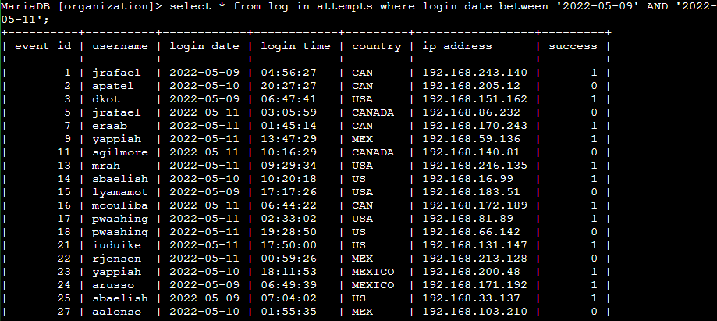

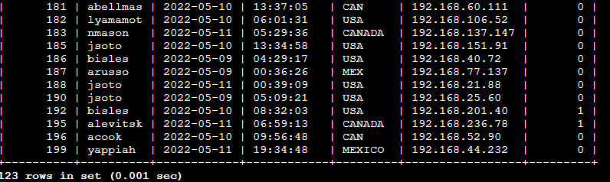

In order to find login attempts on a specific range of dates, we now use the ‘BETWEEN’ keyword with the ‘AND’ keyword like the above image. There are 123 login attempts throughout the specified time frame.

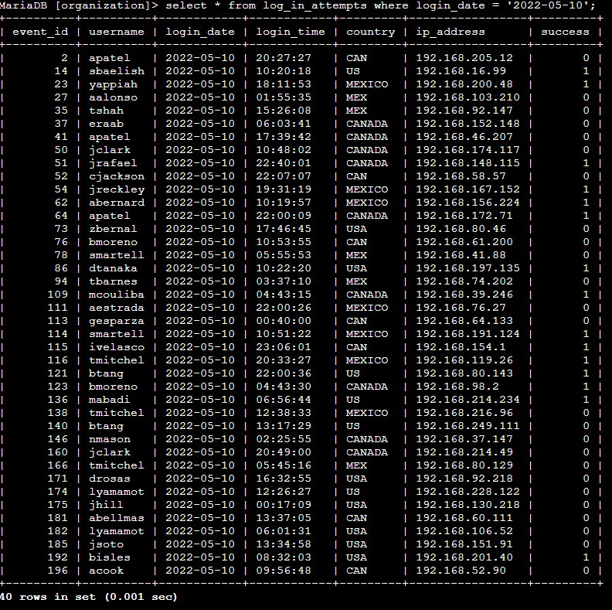

If we only want to find the login_attempts that happen during only one day, we can use the “=” symbol instead. This returns all data with login_date as specified on the command line.

## Retrieve after hours failed login attempts

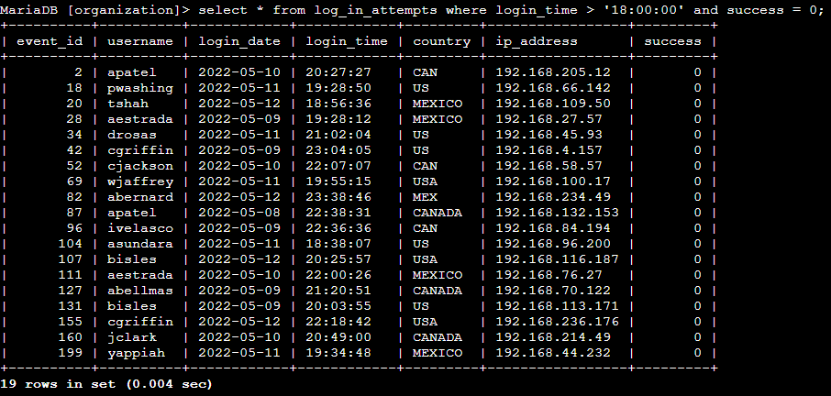

One of my tasks was to find a potential security incident that happened after business hours. In order to do that, I filtered all login attempts that happened after 6pm (18:00:00) which leads to an unsuccessful login attempt. This is done by using the “>” symbol to find login attempts after 6pm and made sure that all the data I filtered are unsuccessful login attempts. The “AND” keyword adds an extra condition on the filter that must be fulfilled, which is when success value is 0 (unsuccessful) here.

## Retrieve login attempts outside of Mexico

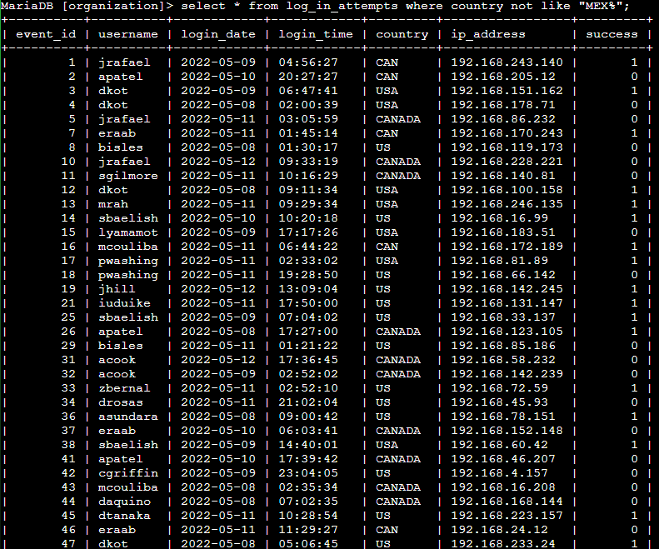

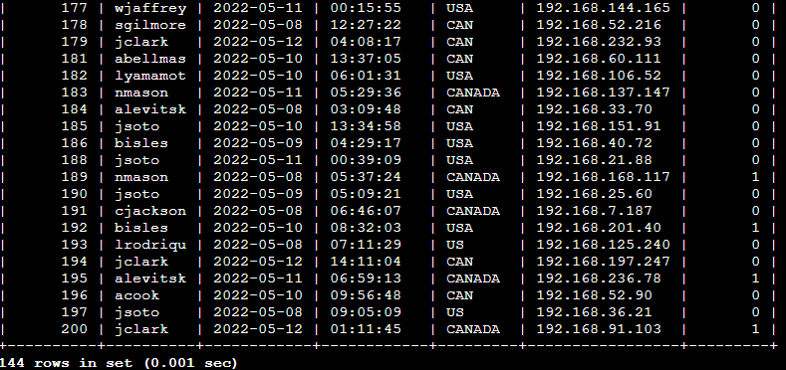

The investigation team determined that the attack did not originate from Mexico, therefore I had to find login attempts data that did not come from Mexico. To do so, I used the “NOT” and “LIKE” keywords. The “NOT” keyword ensures that I do not find data that results in the country Mexico, while the like is used because the ‘country’ data may contain both MEX and MEXICO, where both stands for Mexico. The “%” symbol after MEX ensures that any word which starts with MEX will not be output by the terminal.

## Retrieve employees in Marketing

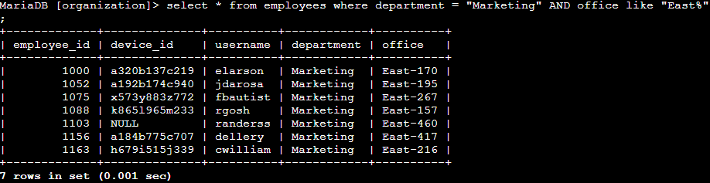

To ensure security, the team needs to perform security updates on employee machines in the Marketing department. We first check all employees in the Marketing department located in the East building. By filtering the department and the office at the same time, I am able to easily filter the employees in the Marketing department located at the East office.

## Retrieve employees in Finance or Sales

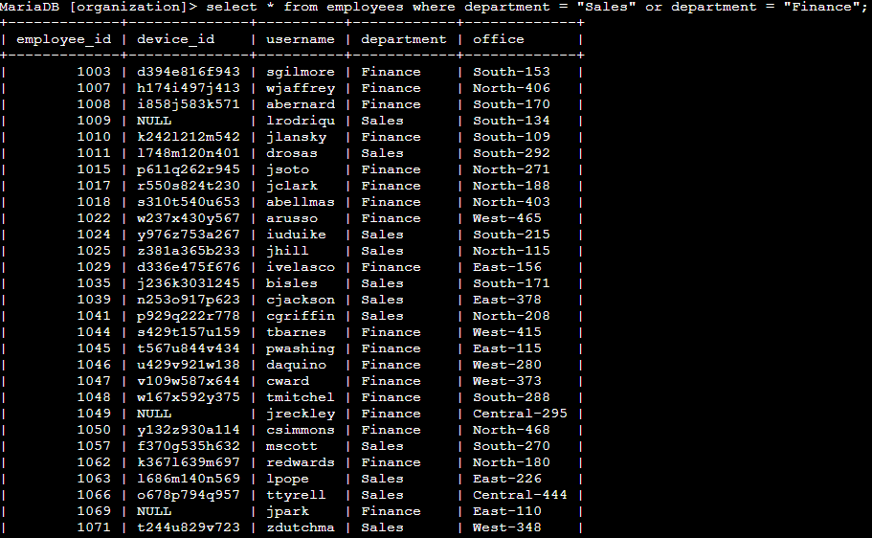

The team intends to perform a security update on machines from employees in both the “Sales” and “Finance department. My task is to filter the table to find all the employees in those departments. This time, I used the “OR” keyword to find all employees in both departments. It works similarly to a union function in sets, taking in all the data that is mentioned in the command line.

## Retrieve all employees not in IT

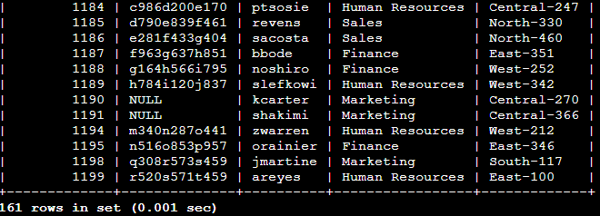

The cybersecurity team informed that the Information Technology department had already finished updating their machines. In order to identify all other employees not in the IT department, I have to filter the employees table with the “NOT” keyword. This ensures that all the employees in every department except Information Technology is shown on the terminal.

## Summary

I applied the filter features of SQL to get specific information on login attempts and employee machines. I filtered two different tables, “log_in_attempts” and “employee”. I used the “AND”, “OR”, “NOT”, “LIKE”, “BETWEEN” keywords or operators to filter specific information based on the given tasks. I also used the “%” symbol to filter patterns and other arithmetic symbols like “<”, “>”, “=”, “<>”, etc as another method to also filter information.